Mean-Reverting Portfolios

Strategy Overview
This document outlines a trading strategy by construction a portfolio, consisting of US equities, such that the historical portfolio value shows a mean-reverting pattern. The strategy is back-tested and implemented in Python utilising Interactive Brokers (IBKR) API infrastructure to obtain real time market data and execution.

Strategy Details

Stock Selection
A total of 55 US stocks are selected for this strategy. Eight stocks with the lowest variance are selected, using Principal Component Analysis (PCA), which will be used to construct the portfolios. Selecting the lowest variance ensure a smooth portfolio values time-series with minimal noise to show the mean-reverting pattern.
A series of portfolios are constructed consisting of different combination of five stocks.

Portfolio Calibration
Each stock in a portfolio is assign a weight, where each weight represent the amount of stocks to hold. In this part of the modelling, I have assumed that the portfolio is able to hold a fraction of stocks. The stocks amount will be converted to an integer amount in the back-testing process, which will depend on the investment amount and stock price.
The calibration involved smoothing the historical portfolio value time series using Savitzky-Golay filter with window size of 31 and polyorder of 10. The filter is used to smooth the time series while preserving features such as peak, height, width, and position. This smoothing model is suitable for low noise time series.
The smoothed time series are then calibrated to Ornstein-Ublenbeck (OU) process using method-of-moment. Method-of-moment involved matching the empirical moments of the observed data to the theoretical moments of OU process.
The calibration is performed by maximising the OU speed of reversion (theta) and minimising the volatility. In Python, I use the scipy library and use the minimize function utilising SLSQP, trust-constr, BFGS, Nelder-mean, and Powell methods. Should the SLSQP fails to achieve convergence, then the optimiser move to the next method and apply different methods.
The calibration result assigns weights to each stock in each portfolio.

Generating Signals
Given the weights and the allocated investment amount for each portfolio, I constructed a time series of the portfolio values over the last 200 historical days, by:
      - allocating the number of shared per stock (i.e., investment amount * weights)
      - smoothing the historical time series using Savitzky-Golay filter
Using the smoothed time series, I calculated the:
- hurst exponent
- half-life
- 10-day simple moving average (SMA)
- OU long term average (mu), and sigma
The technical indicators are used to identify entry trading opportunities:
- hurst exponent < hurst Level
- 0 < half-life < half-life upper limit
- to enter long position:
  - portfolio value < mu and (SMA < mu – sigma * multiplication or SMA > mu + sigma * multiplication)
- to enter short position:
  - portfolio value > mu and (SMA < mu – sigma * multiplication or SMA > mu + sigma * multiplication)
I implemented trailing stop losses to exit positions. The first stop loss is set at 20% of the portfolio value. Once the portfolio reaches 5% profit, then I set the stop loss to 5%.

In-Sample Back-testing
The in-sample back-testing is performed on 250 days historical data, which is used to find the optimal hurst level, SMA multiplication, and half-life upper values. Figure 1 shows the return distribution using parameter values of:
- Hurst level of 0.97
- half-life lower value of 37.75
- half-life upper value of 74.05
- SMA multiplication of 1.35
These values are determined by manually changing the parameters value and it is used as an initial values for optimisation.

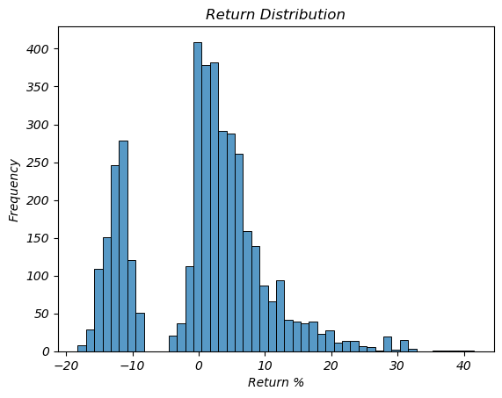Figure 1: non-optimised distribution
As shown in Figure 1, the return distribution resemble two normal distributions. This is a good candidate for a Gaussian Mixture Model (GMM), which I have used to calibrate the parameters. The calibration is aiming to move the two modes of the distribution as far to the right as possible.
The optimisation is performed in Python using the optuna library, which supports multiple parallel optimisation. This increases the optimisation process, since back-testing is quite a slow process. Optuna also does not randomly search, instead it builds a probabilistic model of the objective function and prioritise promising areas. It means the optimised can reach solutions faster with fewer trials compared to grid/random search.
Figure 2 shows the in-sample return distribution using the calibrated parameters of:
- Hurst level of 0.3617
- half-life upper value of 62.3571
- SMA multiplication of 2.0284
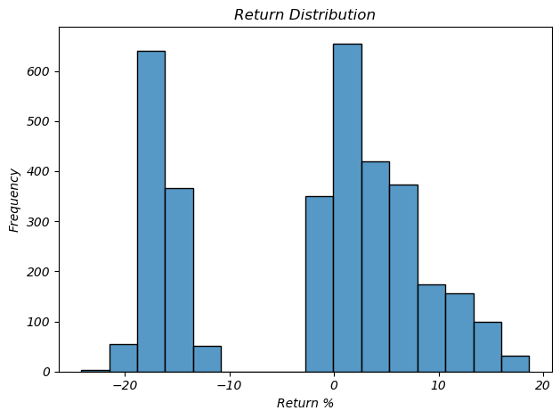
Figure 2: Optimised in-sample return distribution

The mean is located at -17% and 4%, with the weight of the left distribution at 30% and 70% for the right distribution.

Out-Sample Back-testing
The out-sample data is using the latest 3 years historical prices. Figure 3 shows the return distributions using the calibrated parameters set from previous section.
Figure 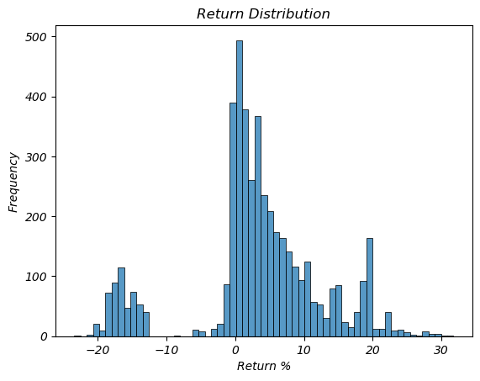3: out-sample distribution

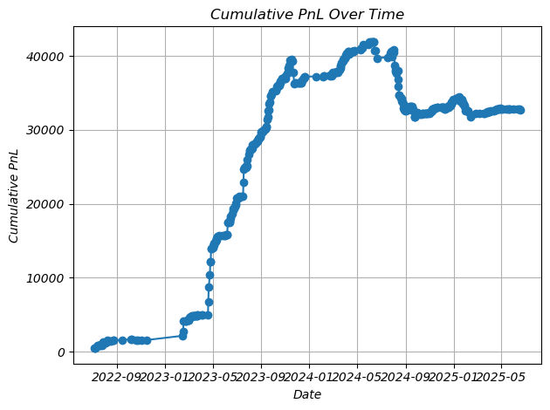Figure 4: cumulative return

Future Improvements
Several ideas for future improvements are:
- Calibrating the hurst, half-life, sma multiplication using Gaussian Mixture Model
- Using different mean reverting model. i.e., CIR, Ho-Lee model
- use different investment amount for each portfolio
- dynamically select the number of stocks per portfolio instead of fix amount
- optimise the stop loss and profit limit.
- Using other technical indicators for signal generation
- more frequent calibration. Maybe daily

The total weight in each portfolio sums to 1.
Currently the allocated investment amount is the same for all portfolio

